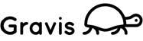
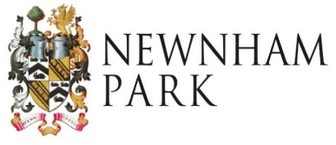
Newnham Solar Community Grant Fund
Sponsor Form for Groups seeking grants of up to £250

Name of organisation offering sponsorship
Name of organisation/group being sponsored
Name, Tel number, e-mail address and position of Sponsor contact for the project.
Project name
Project Cost and Grant Sought | Total Cost:£ Grant Sought:£
Please tick to confirm the following; | - That to the best of your knowledge you believe the group requesting your sponsorship to be legitimate and conforming with our conditions  - That you are prepared to accept payment of a grant on their behalf and ensure that it is used for purpose in the application form.  - That you are prepared in the event that the groups activity ceases to operate, to ensure that any equipment is retained for community use
Information to enable grant payment | Name of Bank:  Bank Account Name:  Account number: Sort Code:
Signed on behalf of organisation
Name in capitals
Designation
Date
Please return the completed application form with all supporting information to
admin@newnhamsolarfund.com or post it to
Newnham Solar Community Fund, 39 Boringdon Park, Ivybridge, PL21 9TY

The information provided in this form will be circulated to the Board of Directors and used to determine your eligibility for a grant award and to communicate with you about the application. Personal details will be held securely, in line with our GDPR Policy and not passed onto third parties.

