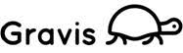
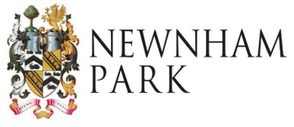
Newnham Solar Community Fund
Hardship Fund Guidance
What is the Newnham Solar Community Fund?
The Newnham Solar Community Fund distributes funds generated by a solar array at Newnham Park, Plympton for the benefit of residents within the parishes of Sparkwell and Shaugh Prior.
It generally supports community projects and initiatives that take place in the two parishes that have environmental, social or economic benefits to the local community.
The Fund is also able to support individual residents from within the two parishes that are experiencing hardship, with one off grants of up to £100. These grants can be used to pay for goods or services to help the individual overcome the immediate issue.
Please read these guidance notes carefully. For advice please contact the Scheme Administrator by email at admin@newnhamsolarfund.com or on 07742 062214.
Who can apply to the fund?
An application for a hardship grant must be made on behalf of the resident by one of the following ‘Referees’; a Parish, District or County Councillor representing Shaugh Prior or Sparkwell Parishes, a Health or Social Care Worker, a GP or another advice professional that has visited the resident at home (or undertaken suitable investigations over the phone to confirm the need).
It is for the Referee to decide that there is a genuine case of hardship and that the individual is unable to resolve the issue in another way.
What the fund can pay for
The following are examples of the type of items/work that the fund can pay for, this list is not exhaustive and other items will be considered if there is a good reason;
- The purchase of essential household items such as white goods
- Topping up a prepayment energy meter, when there is no other option
- Emergency boiler repairs or repairs to white goods/kitchen equipment
- Installation of security measures
- Educational materials
- Other essential items/equipment for the health or educational benefit of the residents

A resident can only apply for one hardship payment in any 12 month period.

The process for applying for a hardship grant
The referee must complete the Hardship Grant application form and submit it to the Scheme Administrator via e-mail at admin@newnhamsolarfund.com. The Directors will consider the application via e-mail and make a decision within 5 working days.
The Scheme Administrator will liaise with the Referee to work out the best way to pay the grant. The grant will not usually be given directly to the resident but used to pay for the work/item directly.
Help and advice on completing the application form
For advice please contact the Community Fund Scheme Administrator at admin@newnhamsolarfund.com

